
VELLORE INSTITUE OF TECHNOLOGY
BHOPAL
PROJECT REPORT
ON
DIGITAL LITREACY

PROJECT REPORT PREPARED BY-
Student Name Ilesh Kumar
Branch B.tech-CSE in AI/ML
Registration number 25BAI10018
Year 1st Year

Introduction
The project is centered on raising awareness about digital literacy and online safety among college students. In this modern world, where digital growth is rapid, online platforms are being used for learning, communication, transactions, and socializing among students. However, this has also created different kinds of cyber threats for them, including phishing, fraud, and misuse of personal information.

The project will involve creating a digital literacy quiz, online safety practices, and understanding different cybercrime scenarios such as UPI fraud. Moreover, it will also focus on safe social media practices and online safety checklists for the students. The scenario will also shed light on how lack of awareness and improper digital literacy can cause serious consequences for them.

Task-1
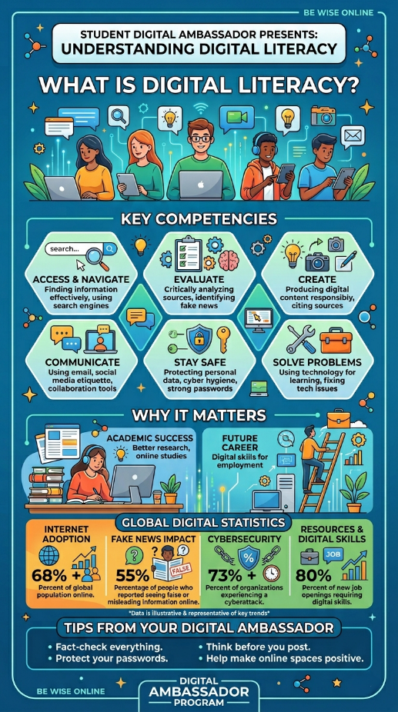
For my project, I designed an infographic about the topic of "digital literacy" with the help of a computer design tool like "Canva." The design displays a clear and interesting description of what "digital literacy" is and why it is important in today’s world. The design includes the key skills that a digitally literate person needs to have, such as "accessing information," "evaluating information," "creating content," "communicating," "staying safe," and "problem-solving." Additionally, the design includes the importance of "digital literacy," such as "academic success," "career opportunities," and "some interesting stats about the digital world." Finally, the design includes "some useful tips" such as "fact-checking information" and "keeping passwords safe."
Something interesting that I learned while making my project was that "digital literacy" includes many different skills that a person needs to have, and it is not just about "using the internet." However, it was a bit hard for me to organize all the information in a neat manner without making the design look too crowded.

Task-2
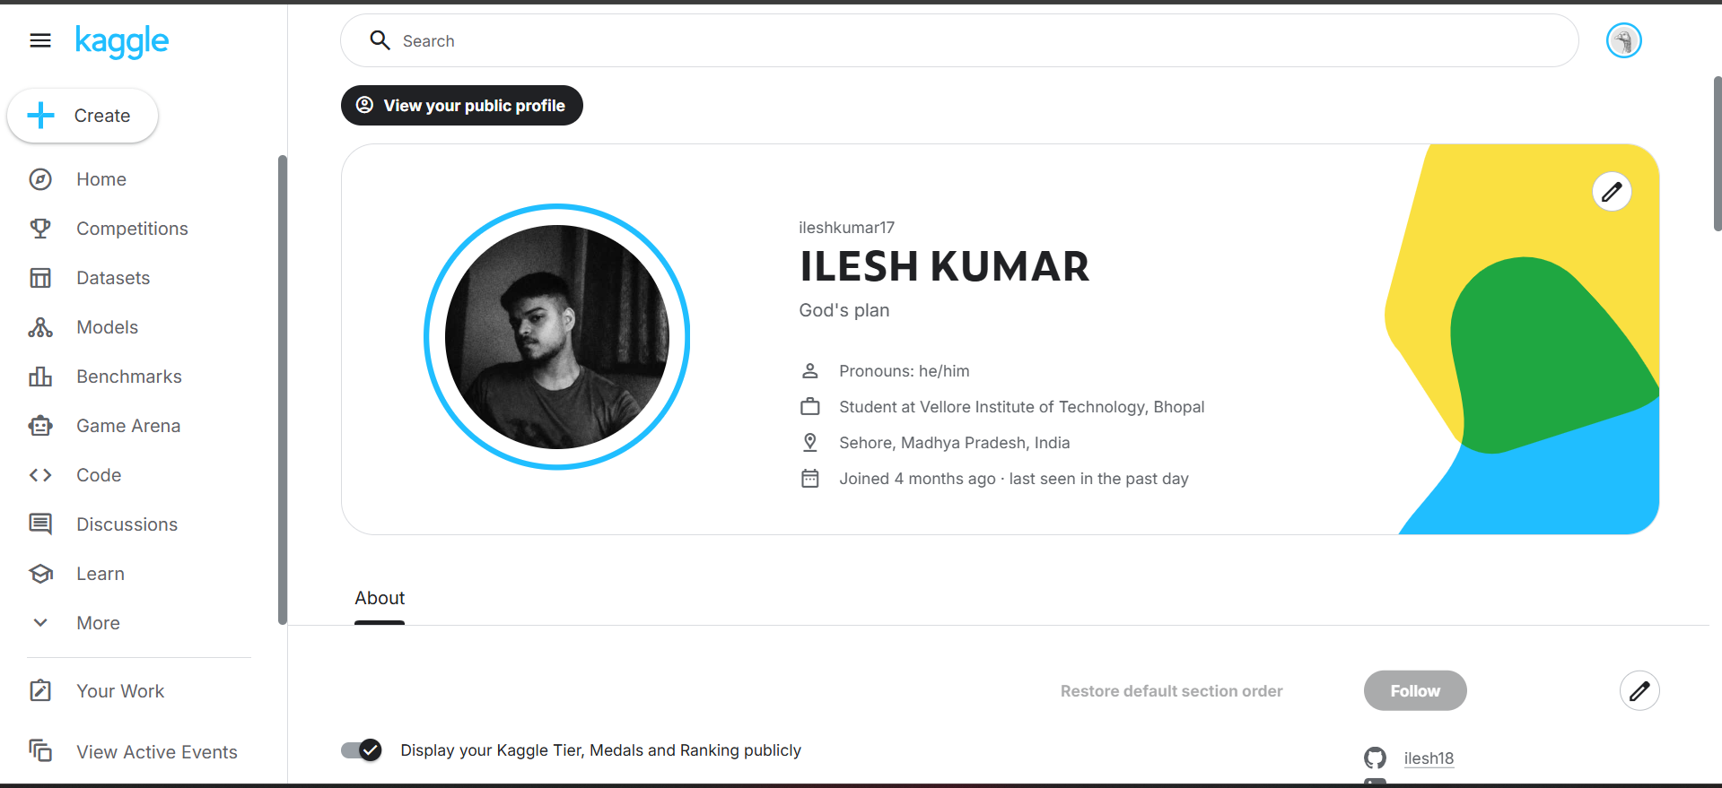
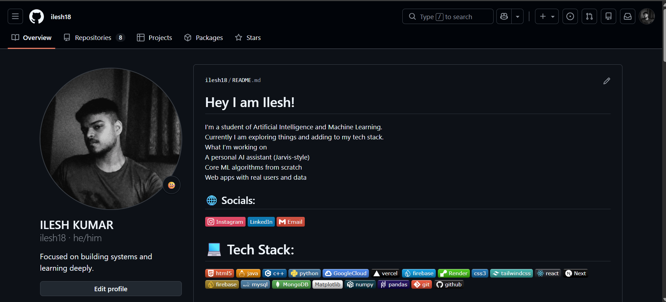
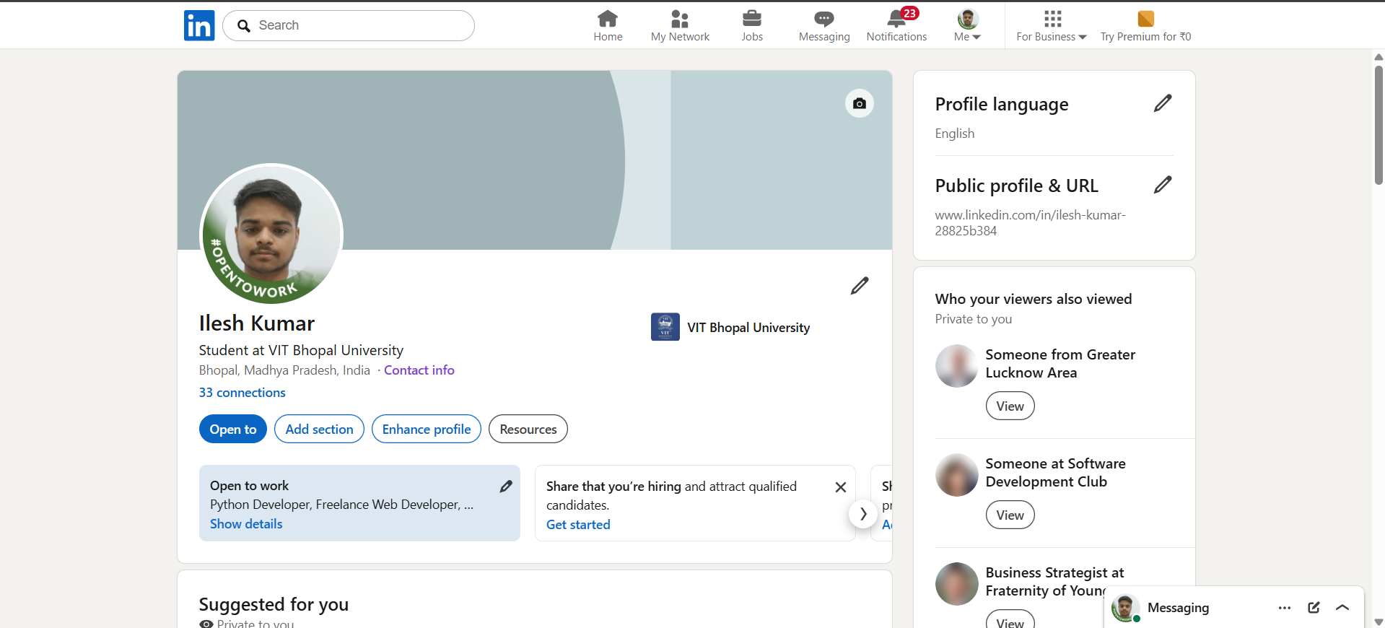
In regard to my professional and academic growth, I have chosen three main platforms: GitHub, Kaggle, and LinkedIn. Each one has a different but equally important role to play in the growth and development of my professional career in the field of Artificial Intelligence and Machine Learning.
GitHub is a platform where I can show my projects and coding skills. I can upload my projects, web applications, AI models, and other personal projects to show my coding prowess. In the next four years, I will be actively contributing to various repositories, working on real-life projects, and collaborating with other developers.
Kaggle is a platform where I can practice my machine learning and data science skills. I can work on various datasets and improve my problem-solving skills. In the coming years, I expect to win medals, develop great notebooks, and achieve recognition in the Kaggle community.
LinkedIn is a professional network where I can share my accomplishments and explore various opportunities. In the coming years, I expect to grow my network, share valuable content, and attract various internship and job opportunities.
These platforms will enable me to grow professionally and academically.

Task-3
For this project, Google Forms was used as the main tool for creating a quiz titled 'Digital Literacy Awareness Quiz'. Google Forms can be used as a powerful tool for creating surveys, quizzes, and questionnaires in a well-organized manner. With Google Forms, a quiz with five different questions, such as multiple-choice, checkboxes, and short answer, can be created, which can be used for testing basic knowledge about digital literacy, for example, online safety, password use, and responsible use of online platforms.
During the process of creating a Google Form, different skills were used, for example, organizing questions, selecting appropriate question types, and adding quiz features, as well as making the quiz more interactive and user-friendly.
These tools can be useful for me academically, for example, in creating digital content, making surveys, and efficiently responding to them. Google Forms can be useful in the future for different projects, research, and collecting feedback from different individuals. Additionally, Google Forms can enhance knowledge about different digital tools, which can be useful for me, especially in the field of Artificial Intelligence and technology.

Task-4
E-mail-1
Subject- Request for Extension on Assignment Submission

Dear Professor,
I hope this letter finds you in the best of health and spirits. I am writing to humbly request an extension of the deadline for the assignment that is to be submitted by the end of the course.
Unfortunately, due to unforeseen circumstances, I have not been able to complete the assignment to the best of my abilities within the given period of time. I realize the importance of submitting the assignment on time and take complete responsibility for the same. I would greatly appreciate it if I could be granted an extension of the deadline to submit the assignment.
I would like to assure you that I am committed to completing the assignment as soon as possible. Please consider my request.
Thank you.

Sincerely,
Ilesh Kumar

E-mail-2
Subject- Application for Summer Internship Opportunity

Dear Sir/Madam,
I hope this message finds you in the best of health and spirits. I am writing this letter to express my interest in a summer internship program with your esteemed organization.
I am a student currently pursuing a degree in Artificial Intelligence and Machine Learning, and I wish to apply my knowledge in a real-time environment. I have hands-on experience with technologies like Python, web development tools, and machine learning basics. I am highly motivated to learn, contribute, and grow with hands-on experience.
I would be highly grateful if you could consider me for an internship position in your esteemed organization. Please let me know whether there are any available positions in your organization or whether you require any additional information from me, like my resume or portfolio.
Thank you for your time and consideration.

Sincerely,
Ilesh Kumar

PROJECT REPORT FOR THE CHECKLIST

If there is poor digital communication, it can lead to major misunderstandings, especially in academic or professional situations. A good example is when a group of students are working on a project, and one of them sends a message like, “I’ll handle the report.” This means different things to different people, and everyone assumes all is well. On the day of submission, it is discovered that the report is incomplete because of poor communication, and everyone in the group gets poor grades because of this single reason. This would have been avoided through proper and clear digital communication. The student would have clearly stated what they would handle, and everyone would have known. This would have helped avoid many problems. Proper digital communication involves clarity, updates, and understanding.

Task-5
Project report for prevention list
While conducting my research on this topic, what surprised me most was how simple and small mistakes can lead to major cyber crimes. For instance, even clicking on an unknown link or entering my UPI PIN without knowing the reason can cause me to lose money instantly. Another thing that surprised me was how convincingly scammers mimic bank or company profiles or even my known contacts, making it really hard to identify them as fraudsters.
So, as a personal habit that I will definitely adopt in my life is to be more cautious before performing any action online. I will make it my habit to always verify each and every link/message/payment before responding to it. I will also avoid rushing into any decision, especially in situations that call for time sensitivity. This will definitely help me stay alert and save me from all possible online threats.

Conclusion:
This project helped me understand the importance of digital literacy and responsible online behaviour in today’s world. I learned how small mistakes, such as clicking unknown links or sharing sensitive information, can lead to serious consequences like cyber fraud. Creating the quiz, checklist, and case study improved my practical understanding of online safety and communication. Overall, this project has made me more aware, cautious, and confident in using digital platforms responsibly.

References:
- Google Forms (for quiz creation)
- National Cyber Crime Portal (https://cybercrime.gov.in)
- General awareness articles on cyber safety and UPI fraud

